LEDs e potenciômetro:

O projeto abaixo foi feito usando C++
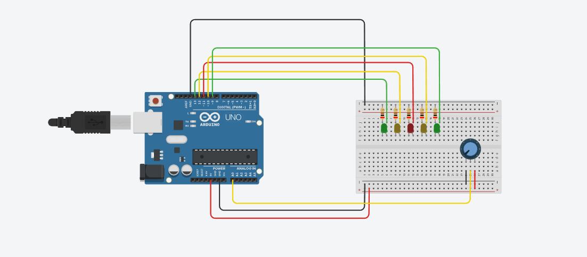
Código do projeto:
// C++ code
//
int valor =0;
void setup() {
pinMode (9,OUTPUT);
pinMode (10,OUTPUT);
pinMode (11,OUTPUT);
pinMode (12,OUTPUT);
pinMode (13,OUTPUT);
pinMode (A0,INPUT);
}

void loop() {
valor = analogRead(A0);
if(valor<180){
digitalWrite(13, LOW);
digitalWrite(12, LOW);
digitalWrite(11, LOW);
digitalWrite(10, LOW);
digitalWrite(9, LOW);
}
else if(valor<360){
digitalWrite(13, HIGH);
}
else if (valor<540){
digitalWrite(13, HIGH);
digitalWrite(12, HIGH);
}
else if (valor<720){
digitalWrite(13, HIGH);
digitalWrite(12, HIGH);
digitalWrite(11, HIGH);
}
else if(valor<900){
digitalWrite(13, HIGH);
digitalWrite(12, HIGH);
digitalWrite(11, HIGH);
digitalWrite(10, HIGH);
}
else if(valor>900){
digitalWrite(13, LOW);
digitalWrite(12, LOW);
digitalWrite(11, LOW);
digitalWrite(10, LOW);
digitalWrite(9, LOW);
delay(100); // Wait for 100 millisecond(s)
digitalWrite(13, HIGH);
delay(100); // Wait for 100 millisecond(s)
digitalWrite(13, LOW);
digitalWrite(12, HIGH);
delay(100); // Wait for 100 millisecond(s)
digitalWrite(12, LOW);
digitalWrite(11, HIGH);
delay(100); // Wait for 100 millisecond(s)
digitalWrite(11, LOW);
digitalWrite(10, HIGH);
delay(100); // Wait for 100 millisecond(s)
digitalWrite(10, LOW);
digitalWrite(9, HIGH);
delay(100); // Wait for 100 millisecond(s)
digitalWrite(9, LOW);
delay(100); // Wait for 100 millisecond(s)
digitalWrite(10, HIGH);
delay(100); // Wait for 100 millisecond(s)
digitalWrite(10, LOW);
delay(100); // Wait for 100 millisecond(s)
digitalWrite(11, HIGH);
delay(100); // Wait for 100 millisecond(s)
digitalWrite(11, LOW);
delay(100); // Wait for 100 millisecond(s)
digitalWrite(12, HIGH);
delay(100); // Wait for 100 millisecond(s)
digitalWrite(12, LOW);
delay(100); // Wait for 100 millisecond(s)
digitalWrite(13, HIGH);
delay(100); // Wait for 100 millisecond(s)
digitalWrite(13, LOW);
}
}

